The device concentrates the suns rays into a central collector, which heats a bottle of water from the inside. As a result, the energy tends to be safely stored inside the bottle.

The parts of the device comprise of;

|  |  |
| --- | --- |
| Parabolic reflector (Reflector) | A reused/recycled Satellite TV dish. The essential design of any these dishes, means a focal point ~0.5m away from the reflector. |
| Reflective material | The reflective material can be either reflective gift wrapping paper or Aluminum foil. Both are laid down in strips on the said Reflector to create a parabolic mirror |
| Bottle | Fully transparent, non-tinted bottle, ideally glass (plastic will also do, though durability will be compromised) |
| PVC pipe (Collector) | Dark grey PVC pipe. Best prepared when wrapped with a metal foil (colored black for increased absorption) |

Figure 1: The parabolic mirror is positioned in such that the focal point falls on the said Collector

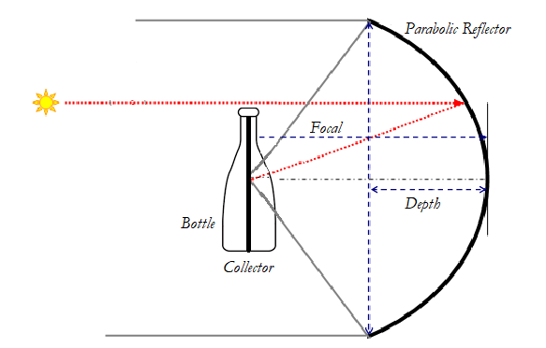

Figure 2: Parabolic Dish

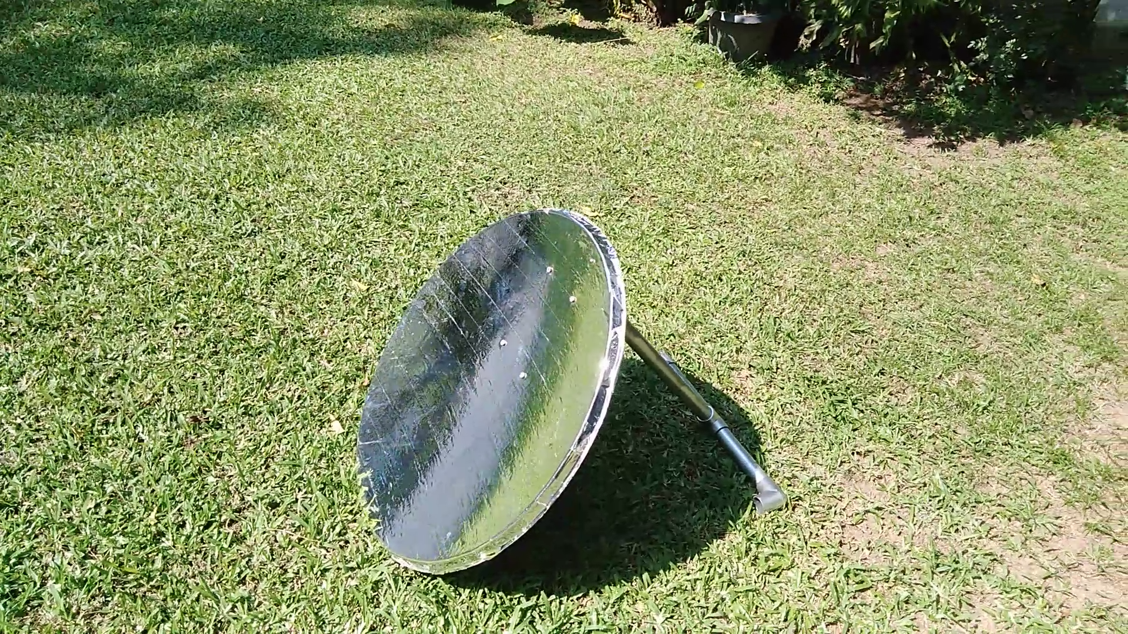

Figure 3: Real World Setup